John Opie
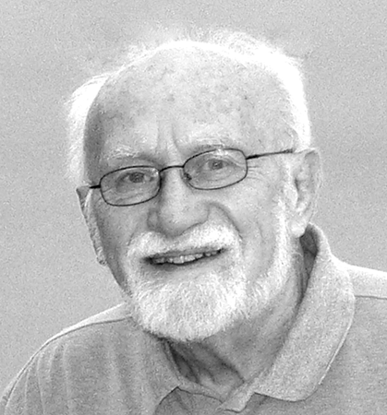

Philosophy
I have a bad habit. I rarely go out of the house, bike a pathway, travel to a meeting, or journey to my favorite hideaway deep in Canyonlands, without my camera. I see the world through a camera’s lens. My memories of places and people are wired into my photos. This is a risky enterprise because it can be so limiting. But as George Shaub, the editor of Shutterbug magazine wrote, “What I really like about photography is how it skins my eyes. It’s what practitioners of Zen might call the ‘slap of consciousness.’” Shaub added, “I travel with eyes wide open.” This reminds me of Ralph Waldo Emerson’s quest to become “a transparent eyeball,” nakedly open to the external world. Nevertheless, we also carry mental baggage that shapes the images we make. My goal is to unveil the inner realities of the outside world. Very often the exact photo image only hints at the inner reality.
Above all, I seek to be an artist. I recognize that art is in the mind of the beholder, no matter what statement I am trying to make. Contrarily, I also recognize that I seek to uncover the beauty inherent in both natural and man-made objects. I aspire to the sublime while also celebrating the transformation of the commonplace. My work, whether abstract, symbolic, or representational, offers both a specific statement of the larger world and an expression of inner life.

Primary Photographic Modes
My photo shooting has been both 35mm film and digital. Depending on what I see in the image, I do minimal correction. My digital manipulation can also be extensive, using Photoshop and Nik software. My interests today are toward digital art abstractions, panoramics, and monochrome prints, as well as a long-standing affection for reflections, backlighting, vivid colors lit by the morning or afternoon sun, and iconic American landscapes.

Competitions
Regional juried awards have been a First Place in the 2010 Penitentiary Glen Nature Center photo competition, First and Second Place in the 2010 AOPHA regional competition, and acceptance in the 2010 Lakeland Community College Art Competition. I also had a one-man show at the Osborne Center of Breckenridge Village in 2010. My photos have also been in 24 juried shows at the Chicago Artists Coalition, Kalamazoo Institute of Arts, Box Factory for the Arts (St. Jo. MI), Elkhart Museum of American Art, Southern Shore Art Association and Lubeznik Center for the Arts (both in Michigan City IN). Recognition also came from the Twin City Camera Club (Monochrome Print of the Year 2005, Color Print of the Year 2004), and when I was a teenager, four awards in the national Ansco-Scholastic Photography Competition, including First Place and Grand Award (1951, 1952).

John Opie, resides at 53 Ranch Road, Willoughby OH 44094. Now retired, he taught history at Duquesne University, New Jersey Institute of Technology, and the University of Chicago.
440-942-7770; joscribbler@oh.rr.com December 2012

